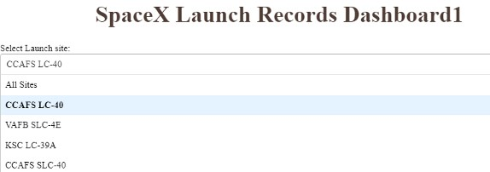

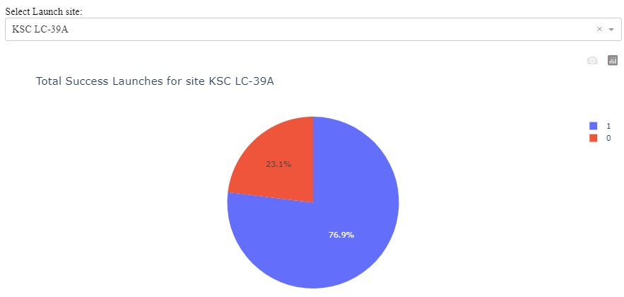

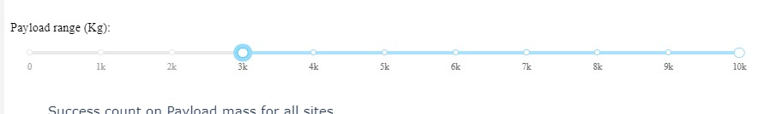

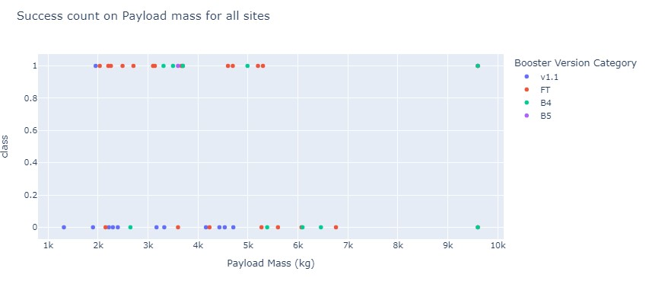

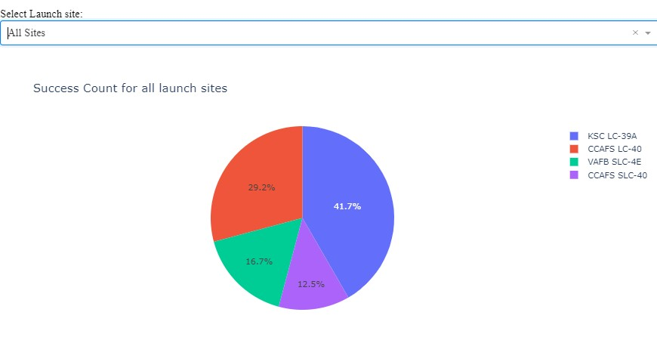

import pandas as pd

import dash

import dash_html_components as html

from dash import dcc

from dash.dependencies import Input, Output

import plotly.express as px

# Read the airline data into pandas dataframe

spacex_df = pd.read_csv("spacex_launch_dash.csv")

max_payload = spacex_df['Payload Mass (kg)'].max()

min_payload = spacex_df['Payload Mass (kg)'].min()

# Create a dash application

app = dash.Dash(__name__)

# Create an app layout

app.layout = html.Div(children=[html.H1('SpaceX Launch Records Dashboard1',

style={'textAlign': 'center', 'color': '#503D36',

'font-size': 40}),

# TASK 1: Add a dropdown list to enable Launch Site selection

# The default select value is for ALL sites

html.Div([#TASK 2.2: Add two dropdown menus

html.Label("Select Launch site:"),

dcc.Dropdown(

id='site-dropdown',

options=[{'label': 'All Sites', 'value': 'ALL'},

{'label': 'CCAFS LC-40', 'value': 'CCAFS LC-40'},

{'label': 'VAFB SLC-4E', 'value': 'VAFB SLC-4E'},

{'label': 'KSC LC-39A', 'value': 'KSC LC-39A'},

{'label': 'CCAFS SLC-40', 'value': 'CCAFS SLC-40'}

]

,

placeholder='.Select a Launch type',

searchable=True

)

]),

html.Br(),

# TASK 2: Add a pie chart to show the total successful launches count for all sites

# If a specific launch site was selected, show the Success vs. Failed counts for the site

html.Div(dcc.Graph(id='success-pie-chart')),

html.Br(),

html.P("Payload range (Kg):"),

# TASK 3: Add a slider to select payload range

dcc.RangeSlider(id='payload-slider',

min=0,

max=10000,

step=1000,

value=[min_payload, max_payload]

),

# TASK 4: Add a scatter chart to show the correlation between payload and launch success

html.Div(dcc.Graph(id='success-payload-scatter-chart')),

])

# TASK 2:# TASK 2:

# Add a callback function for `site-dropdown` as input, `success-pie-chart` as output

@app.callback(Output(component_id='success-pie-chart', component_property='figure'),

Input(component_id='site-dropdown', component_property='value'))

def get_pie_chart(entered_site):

filtered_df = spacex_df

if entered_site == 'ALL':

fig = px.pie(filtered_df, values='class',

names='Launch Site',

title='Success Count for all launch sites')

return fig

else:

# return the outcomes piechart for a selected site

filtered_df=spacex_df[spacex_df['Launch Site']== entered_site]

filtered_df=filtered_df.groupby(['Launch Site','class']).size().reset_index(name='class count')

fig=px.pie(filtered_df,values='class count',names='class',title=f"Total Success Launches for site {entered_site}")

return fig

# Add a callback function for `site-dropdown` as input, `success-pie-chart` as output

# TASK 4:

# Add a callback function for `site-dropdown` and `payload-slider` as inputs, `success-payload-scatter-chart` as output

@app.callback(Output(component_id='success-payload-scatter-chart',component_property='figure'),

[Input(component_id='site-dropdown',component_property='value'),

Input(component_id='payload-slider',component_property='value')])

def scatter(entered_site,payload):

filtered_df = spacex_df[spacex_df['Payload Mass (kg)'].between(payload[0],payload[1])]

# thought reusing filtered_df may cause issues, but tried it out of curiosity and it seems to be working fine

if entered_site=='ALL':

fig=px.scatter(filtered_df,x='Payload Mass (kg)',y='class',color='Booster Version Category',title='Success count on Payload mass for all sites')

return fig

else:

fig=px.scatter(filtered_df[filtered_df['Launch Site']==entered_site],x='Payload Mass (kg)',y='class',color='Booster Version Category',title=f"Success count on Payload mass for site {entered_site}")

return fig

# Run the app

if __name__ == '__main__':

app.run_server()